**1)Difference between node JS vs browser JS**

**NODE JS**

* Node JS is JavaScript runtime environment
* We can run JavaScript outside the browser with the help of Node JS
* NodeJS does not have capability to add HTML tags
* NodeJS is written in C, C++ and JavaScript
* Front end

**BROWSER JS**

* In addition to JS engine also has rendering engine for rendering the page
* Based on the browser v8 for chrome spider monkey for Firefox
* Thread pool in case of chrome it is managed IO thread
* Es6 module system
* Backend

**2)How does the browser render a website**

* When user search on browser , the browser send request to the server in turn server send the response to the browser
* Parsing the HTML document and convert elements to DOM nodes in a tree called the “content tree” – HTML Parser
* Parse the style data, both in external CSS files and in style element together with visual instruction in HTML will be used to create another tree, call “render tree”-CSS Parser
* After the construction of the render tree it goes through a “layout” process. This means giving each node the exact coordinates where it should appear on the screen .
* The next stage is painting the render tree will be traversed and each node will be painted using the UI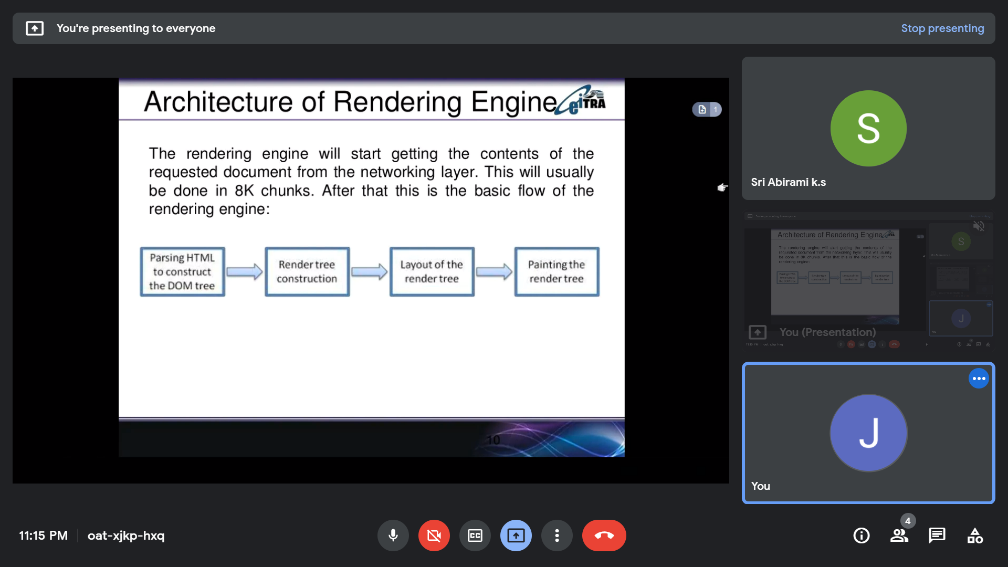

**4)type of**

console.log(typeof(1));

console.log(typeof(1.1))

console.log(typeof('1.1'))

console.log(typeof(true))

console.log(typeof(null))

console.log(typeof(undefined))

console.log(typeof([]))

console.log(typeof({}))

console.log(typeof(NaN))

**Output:**

number

number

string

Boolean

object

undefined

object

object

number

**Explanation**

Type of value refers to data type of value .

Integer, float, nan are the data type of number.

True, false are the data type of Boolean

Null, array, brackets are the data type of object

Undefined data type is undefined